***Join Us For OCBR’s 27th Annual***

# ***Oklahoma Classic Bronco RoundUp 2025***

***September 17-20, 2025***

***Hot Springs ORV Park, Hot Springs Arkansas***

***Food, Fun, WHEELIN’ & Friends***

***ALL BRONCOS ARE WELCOME!***

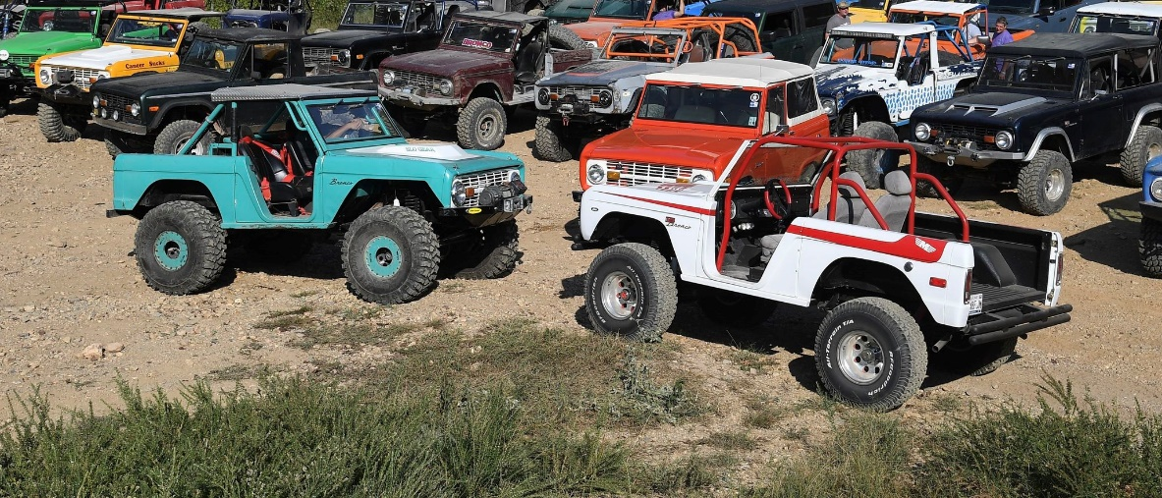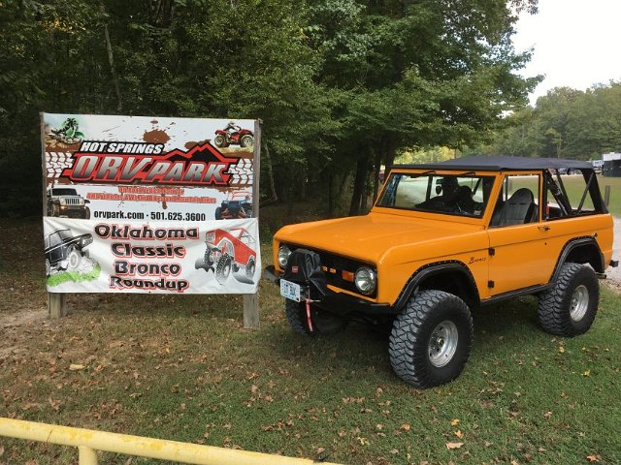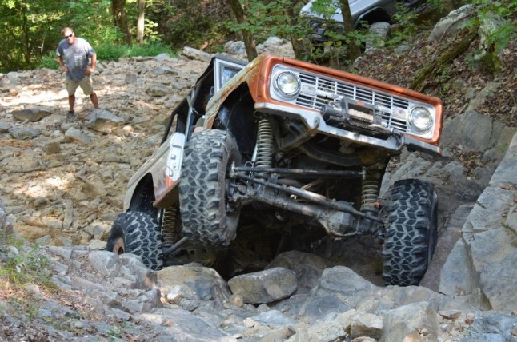

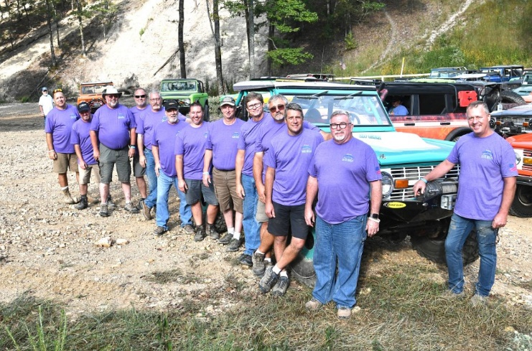 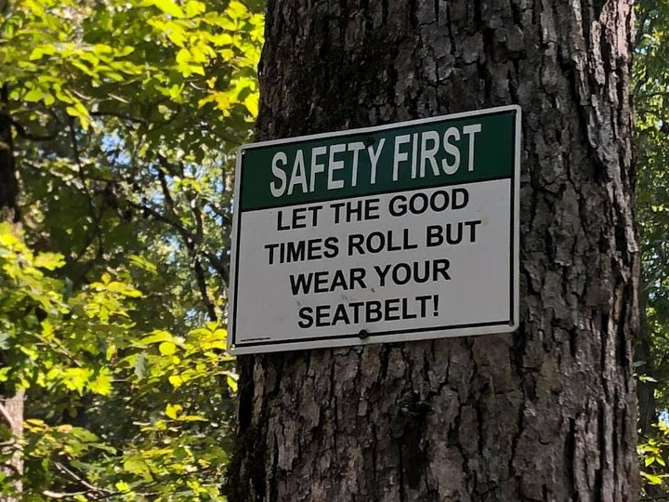

[***www.okclassicbroncos.net***](http://www.okclassicbroncos.net) ***(& on FB)***

[***2Broncos2Go@cox.net***](mailto:2Broncos2Go@cox.net) ***(918) 636-1467***